**Out fitters jeans for girls**

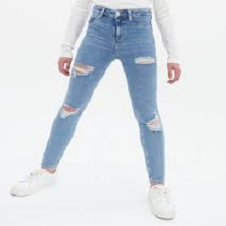

DAMAGE JEANS

PKR 3990

Jean size : 14

jeans waist: 35

**MORE INFORMATION:**

|  |  |
| --- | --- |
|  | |
| **Color** | White & light blue |
| **Product Category** | Ladies jeans |
| **Volume** | Volume 3 2021 |
| **Collection** | Midwinter '21 |
| **Fabric** | Stichable |
| **Disclaimer** | Due to the photographic lighting & different screen calibrations, the colors of the original product may slightly vary from the picture |

**More colors**  Neavy blue , Skin color